Numpy 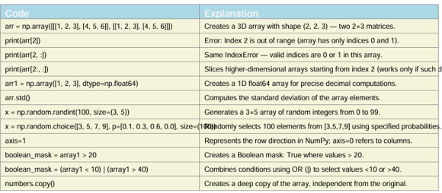
Pandas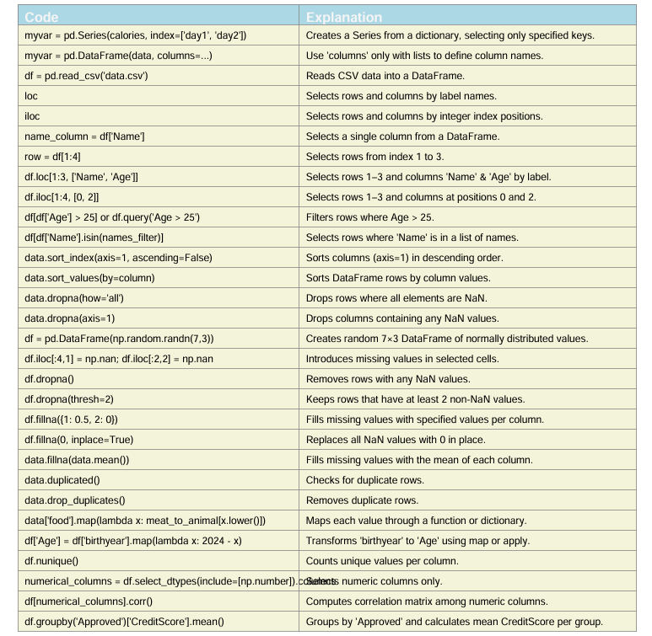
Data Visualization
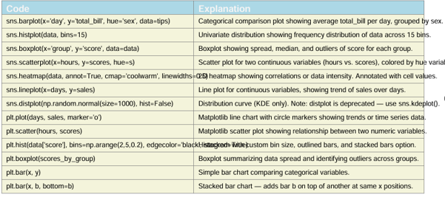
Webscraping 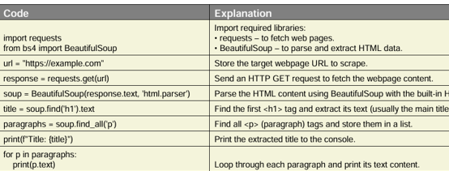
Q2 import numpy as np  matrix_A= np.random.randint(1,11,size=(3,3))  print(matrix_A)  identity_matrix = np.eye(3, dtype = int)  print(identity_matrix)  result_matrix = matrix_A*identity_matrix  print(result_matrix)  sum_result_matrix = result_matrix.sum()  print(sum_result_matrix)  print(result_matrix[0:2,1:]) | Q3 import pandas as pd  import numpy as np  df = pd.read_csv('C:\\inventory.csv')  display(df.isnull.sum())  display(df.duplicated.sum())  display(df.drop_duplicated(inplace =True))  display(df.fillna(df.mean()))  df['Total_inventory_value'] = df['Quantity']*df['Price']  display(df.groupby['Category']  ['Total_inventory_value'].sum())  display(df.groupby('Category')['Quantity'].sum())  display(df.groupby('Category')['Price'].mean())  df['threshold'] = df[df['Quantity']<10]  display(df['threshold']) | Q5 from bs4 import BeautifulSoup  import requests  import pandas as pd  # # Website Link  url = 'http://example.com/movies'  response = requests.get(url)  soup = BeautifulSoup(response.text, 'html.parser')  movies = soup.find_all('div', class_='movie')  title = []  release_dates = []  ratings= []  genres=[]  for movie in movies:  title.append(movie.find('h2',class_= 'title'))  release_dates.append(movie.find('span',class_= 'release_year'))  ratings.append(movie.find('span',class_= 'rating'))  genres.append(movie.find('span',class_= 'genre'))  df = pd.DataFrame({  'Title': title,  'Release Date': release_dates,  'Rating': ratings,  'Genre': genres  })  display(df)  print(df[df['Rating']>=7.0])
Q1 def main(): try:
# Step 1: Read the file
with open("quotes.txt", "r", encoding="utf-8") as file:
quotes = [line.strip() for line in file if line.strip()] # remove blank lines
# Step 2: Display total number of quotes
total_quotes = len(quotes)
print(f"\n📘 Total number of quotes: {total_quotes}")
# Step 3: Prompt the user for a keyword
keyword = input("\n🔍 Enter a keyword to search for: ").strip().lower()
# Step 4: Search for quotes containing the keyword
matching_quotes = [quote for quote in quotes if keyword in quote.lower()]
# Step 5: Display results
print(f"\n✨ Quotes containing '{keyword}':")
if __name__ == "__main__":
main()

q4 import pandas as pd
import matplotlib.pyplot as plt
import numpy as np
# Create a sample dataset
months = pd.date_range(start="2023-01-01", periods=24, freq="M") # two years
regions = ['North', 'South', 'East', 'West']
data = []
np.random.seed(42)
for region in regions:
for month in months:
data.append({
'month': month,
'region': region,
'product_A_sales': np.random.randint(100, 500),
'product_B_sales': np.random.randint(150, 550),
'product_C_sales': np.random.randint(200, 600)
})
df = pd.DataFrame(data)
print(df.head())
✅ 1️⃣ Line Chart — Monthly Sales Trends for Product A & B in North Region
Goal: Show sales trends over time for product_A and product_B in the North region.
python
Copy code
# Filter North region data
north_df = df[df['region'] == 'North']
# Plot
plt.figure(figsize=(10,6))
plt.plot(north_df['month'], north_df['product_A_sales'], marker='o', label='Product A', color='blue')
plt.plot(north_df['month'], north_df['product_B_sales'], marker='s', label='Product B', color='orange')
plt.title('Monthly Sales Trends (North Region)')
plt.xlabel('Month')
plt.ylabel('Sales')
plt.legend()
plt.grid(True)
plt.xticks(rotation=45)
plt.tight_layout()
plt.show()
north_df = df[df['region'] == 'North']
# Plot
plt.figure(figsize=(10,6))
plt.plot(north_df['month'], north_df['product_A_sales'], marker='o', label='Product A', color='blue')
plt.plot(north_df['month'], north_df['product_B_sales'], marker='s', label='Product B', color='orange')
plt.title('Monthly Sales Trends (North Region)')
plt.xlabel('Month')
plt.ylabel('Sales')
plt.legend()
plt.grid(True)
plt.xticks(rotation=45)
plt.tight_layout()
plt.show()
plt.figure(figsize=(8,5))
plt.hist(df['product_C_sales'], bins=10, color='green', edgecolor='black')
plt.title('Distribution of Monthly Sales — Product C (All Regions)')
plt.xlabel('Sales')
plt.ylabel('Frequency')
plt.grid(axis='y', alpha=0.75)
plt.show()
region_sales = df.groupby('region')[['product_A_sales', 'product_B_sales', 'product_C_sales']].sum()
# Create stacked bar chart
region_sales.plot(kind='bar', stacked=True, figsize=(8,6), color=['#1f77b4', '#ff7f0e', '#2ca02c'])
plt.title('Total Sales by Region and Product')
plt.xlabel('Region')
plt.ylabel('Total Sales')
plt.legend(title='Product')
plt.tight_layout()
plt.show()
colors = {'North':'red', 'South':'blue', 'East':'green', 'West':'purple'}
plt.figure(figsize=(8,6))
for region, color in colors.items():
region_data = df[df['region'] == region]
plt.scatter(region_data['product_A_sales'], region_data['product_B_sales'],
color=color, label=region, alpha=0.7)
plt.title('Relationship Between Product A and Product B Sales')
plt.xlabel('Product A Sales')
plt.ylabel('Product B Sales')
plt.legend(title='Region')
plt.grid(True)
plt.show()

